Automating HTML Deployment

**Objective**

Use Ansible to copy an index.html file from the Ansible master to a slave machine and ensure the file is served by Nginx.

**Pre-requisites**

1. **Ansible Master**:
   * Ansible is installed (sudo apt install ansible or equivalent for your OS).
   * SSH access to the slave machine is configured with key-based authentication.
   * Inventory file is set up to define the slave machine.
2. **Slave Machine**:
   * Nginx is installed and running.
   * Proper permissions are configured for the Nginx root directory.

**Steps**

**Step 1: Create Your Ansible Inventory File**

1. Create a file named inventory in your Ansible project directory

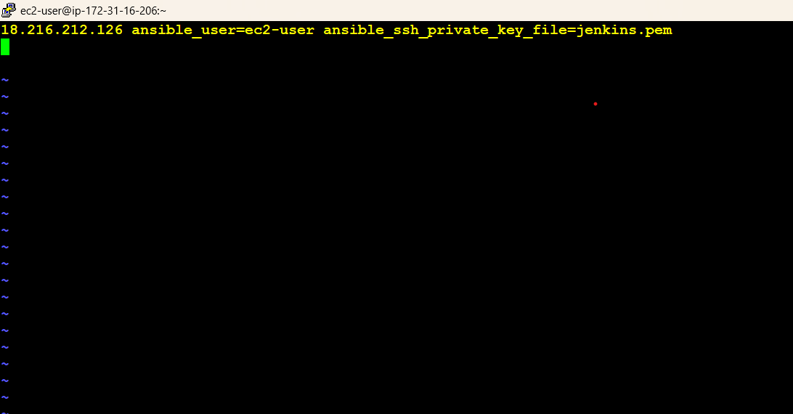

* + Replace 192.168.1.10 with the IP of your slave machine.
  + Update the ansible_user and ansible_ssh_private_key_file based on your setup.

**Step 2: Write the ADHOC Commands:**

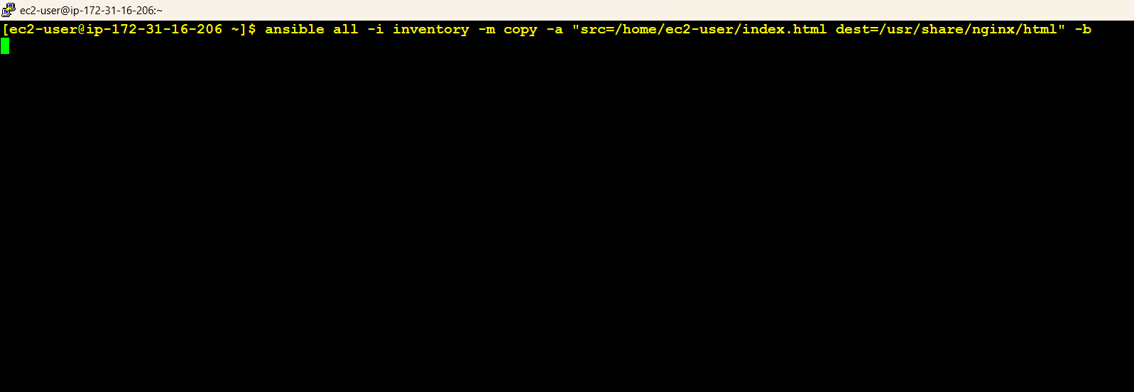

**Full Explanation:**

The line tells Ansible:

1. Connect to the host at 18.216.212.126.
2. Use the ec2-user as the SSH username.
3. Use the private key file jenkins.pem for authentication

**Step 3: Place Your HTML File**

Save your index.html file in the specified path on the Ansible master (e.g., /path/to/index.html).

**Step 4: Verify the Deployment**

1. Open a browser and navigate to http://192.168.1.10 (replace with the slave's IP address).
2. You should see the content of the index.html file displayed.

**Output:**

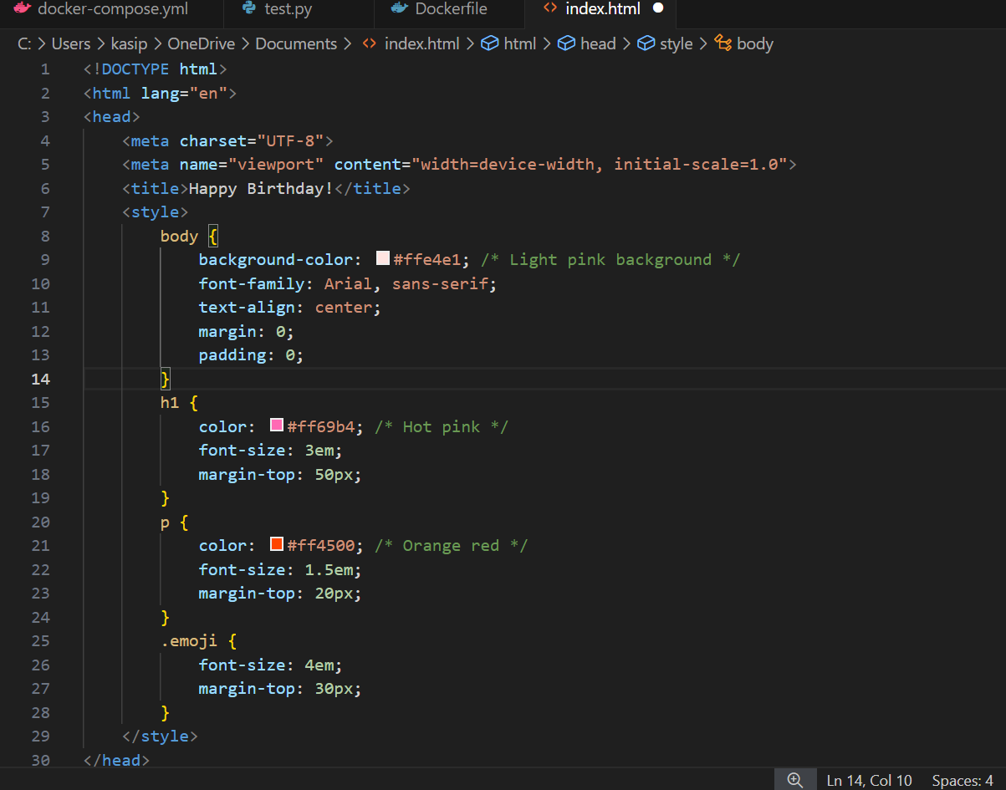



**Conclusion:**

This setup demonstrates how to automate the delivery of an index.html file using Ansible and ensures it is served by Nginx on the slave machine. You can expand this by integrating more tasks, such as backing up old files or managing multiple servers.